The best place for a Maritime Degree is AMC
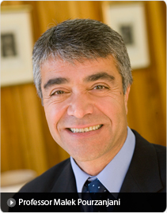
The AMC is a truly international organization, ranking amongst the top maritime higher education institutions in the world. Our ethos is one of responsiveness to our students and to the industries that drive our courses.
We are committed to providing our students with the best range of practical learning and industry-related experience. We pride ourselves on being a student-centered, friendly environment with small class sizes where our academics work closely with students to develop their skills, knowledge and competencies.
The maritime industry is an exciting and diverse area and employers rely on the AMC to supply highly skilled and job-ready graduates through quality teaching and learning, and industry relevant courses.
Our courses are designed for careers. The AMC's graduate employment rate approaches 100% because we have the support of industry and boast a unique suite of world class research facilities. Close relationships with the largest employers in the maritime industry ensure ongoing and expanding opportunities for our graduates.
This promises to be another exciting year for the AMC and its student body as we further develop and refine the dynamic relationships and opportunities that came with our integration as an institute of the University of Tasmania (UTAS). Beginning in 2007 and taking official effect on January 1, 2008, the integration process ushered in exciting changes to our structure, facility upgrades, and created new synergies with UTAS faculties.
With our first full academic year behind us, the new-look AMC is even better placed in 2009 to enjoy all the advantages that come from focusing our teaching and research work around three national centres:

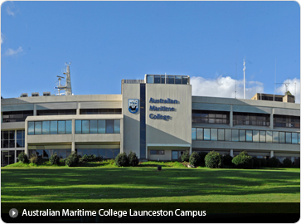
Australian Maritime College – Departments
AMC is made up of three National Centres,
each providing technical knowledge,
practical skills and industry awareness
that give graduates the edge when seeking
maritime employment.

Marine Conservation & Resource Sustainability
Students are taught the skills and develop the knowledge to make decisions that ensure our marine environment's resources are saved for future generations. The centre is responsible for delivering the Bachelor of Applied Science (Marine Environment) degree. Find out more

Maritime Engineering and Hydrodynamics
The centre aims to be an international leader in the maritime engineering sector, renowned for excellence and innovation in education, training and research. It is responsible for delivering the Bachelor of Naval Architecture, Bachelor of Marine and Offshore Systems and Bachelor of Ocean Engineering degrees. Find out more

Ports and Shipping
This centre's focus is on providing students with real industry understanding whether a graduate chooses to work in the maritime sector or not. Graduates are in high demand working in a diverse range of careers in local, domestic and international markets. The centre delivers courses in Seafaring and Maritime and Logistics Management. Find out more
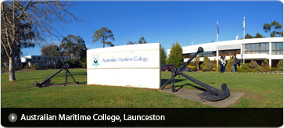

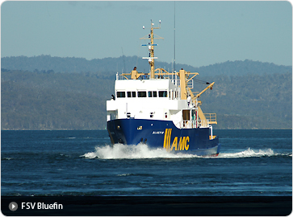
AMC Facilities

Education and Research Facilities
Many of AMC’s facilities are utilised not only for teaching and research but also for consultancy activities. Such collaboration with the maritime industry and allied companies can facilitate access to work experience and employment opportunities for AMC students and graduates.

Vessels
FSV Bluefin is used to familiarise students with environments and tasks they will meet when embarking on their chosen career. Bluefin, AMC’s 34.5m fisheries training vessel, is powered by a Caterpillar D398 main engine and is moored at Beauty Point, Tasmania.
Reviresco is a 14m steel hull, ex-Queensland prawn trawler. It is used for training students in prawn trawling techniques and for research and development, particularly in the field of gear technology.
Stephen Brown, a former collier, is moored permanently at Beauty Point, where it has been renovated for use as a stationary training ship. She is connected to shore power and water to enable the propulsion plant to be operated for training purposes.

Centre for Maritime Simulations
The Shiphandling Simulator is a full scale ship's bridge and 202.5º visuals which is used for evaluating tug requirements and their optimal usage, extending port operational parameters and evaluating proposed new port development, eg. positioning of new berths, extent of channels and turning basin.
The Ship Operations Simulator is used to conduct training programs in bridge operations including high speed navigation. It fully meets the requirements of Section A - 1/12 of the STCW 95 Code: Performance standards for simulators used in training and in assessment of competence.

Towing Tank
The Towing Tank is a fundamental tool utilised by naval architects and other engineering professionals for undertaking physical model experiments within a controlled environment. A major upgrade of the AMC Towing Tank has recently been completed. Among the many improvements, the test section of the tank has been doubled from approximately 40 to 80 metres in length (the overall length has increased from 60m to 100m).
More information on the AMC Towing Tank

Model Test Basin
The Model Test Basin is 35m long and 12m wide, with a flat floor and an adjustable water depth up to 1m. It is equipped with a multidirectional wave maker capable of generating a wide array of wave spectra. Ship models can be towed at varying speeds, up to 4 metres per second.
More information on the AMC Model Test Basin

Flume Tank
The Flume Tank or circulating water channel facility is situated at Beauty Point. The primary function of the facility is to assist with fisheries-related teaching/training and research. The large test section (11m x 5m x 2.5m deep) in the Flume Tank is fitted with a perspex viewing window so that fishing gear and other vehicles/objects can be observed from side on with close scrutiny.

Cavitation Tunnel
The Cavitation Tunnel is a fundamental tool for research and development in Maritime Engineering and more generally in Fluid Mechanics. The tunnel has been developed with broad capabilities to serve the maritime industry, with major applications in propulsion and appendage hydrodynamics and in general for industrial flow processes that occur in such machinery as pumps, turbines and heat exchangers. Modern design features of the facility include ideal optical access and over-pressure capability.
More information on the AMC Cavitation Tunnel

Engineering Workshops
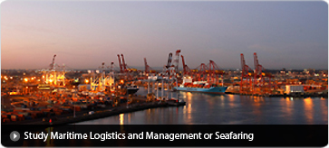
Australian Maritime Safety Authority (AMSA) accredited practical training is conducted using fully-equipped AMC and TAFE workshop and local ship-repair facilities. AMC workshops are equipped with a wide range of modern, operational, shipboard plant and equipment, whilst the TAFE workshops offer up-to-date machining, fitting and welding facilities.
When available, ship repair facilities offer the opportunity to obtain ‘real life’ maintenance skills working aboard ship as part of a repair team. The Machinery Space Simulator is also an important element in practical training for marine engineers.

Australian Maritime Hydrodynamics Research Centre (AMHRC)
The Australian Maritime Hydrodynamics Research Centre (AMHRC) is a major research facility encompassing the Towing Tank, Cavitation Tunnel, Integrated Marine Simulator, Flume Tank and Model Test Basin.

Fatigue Testing Facility
The Fatigue Testing Facility is designed to investigate the flexural fatigue characteristics of aluminium plates and joints and other types of materials such as higher strength steels and fibre reinforced polymers (FRP) composites. The rig has the capacity to test plates of up to 120cm by 60cm with a maximum total load capacity of 40 tonnes.

Emergency Response Centre
The Emergency Response Centre includes the Survival Centre, Marine Firefighting Centre, Damage Control Centre Unit and Fast Rescue Boat. It has been created in order to provide a focus for the major elements of emergency response training.

Survival Centre
Situated on the Newnham campus, the Survival Centre consists of an indoor heated pool and a mock ship’s superstructure, complete with life raft launching facilities and other life saving appliances. A classroom equipped with the life rafts and life saving appliances typical of those currently in use at sea, is situated within the Centre. The Centre is used for the conduct of training exercises, to test new life saving appliances and for some research activities.

Marine Firefighting Training Centre
This facility is located on a 2.4 hectare site at Bell Bay, 45km from AMC and is operated in co-operation with the port and local industry. The Centre is equipped with a full range of modern marine fire-fighting equipment and specialises in practical training, including the control of liquid and gas fires and the use of self-contained breathing apparatus to fight fires in a mock ship structure. All practical training is conducted by experienced training officers.
Personnel from the shipping industry, offshore industry and from ports and terminals in Australia and overseas access courses at this Centre.

Damage Control (Flood) Training
A Damage Control Unit, comprising three floodable compartments, is located on the training vessel Stephen Brown and is used to provide damage control training for civil and Department of Defence Pacific Patrol Boat personnel.

Fast Rescue Boat Training
An R5 fast rescue boat and davit is located on board the training vessel Stephen Brown. Fast Rescue Boat courses are conducted for the offshore and shipping industries for the crews of vessels that carry a fast rescue boat.

AMC Location and Campuses

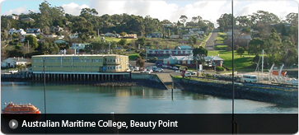
AMC's primary location is northern Tasmania, Australia
There are two main campuses in Tasmania - Launceston (Newnham) and Beauty Point. Our Marine Firefighting Centre is located at Bell Bay, again in northern Tasmania.

Launceston (Newnham) Campus
AMC's administration centre is situated at Newnham, 6 kilometres from Tasmania's second largest city, Launceston. Programs in Marine Conservation, Marine Resource Sustainability, Maritme Engineering, Maritime Operations, Maritime Logistics and Maritime Management are delivered from this campus.

Beauty Point Campus
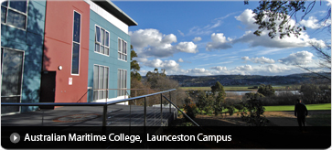
Vessel operations courses are delivered at Beauty Point, about 50 km north of Launceston, near the mouth of the Tamar River. AMC's training and research vessels are moored at Beauty Point. These include FSV Bluefin, Stephen Brown, Skipjack and Riveresco.

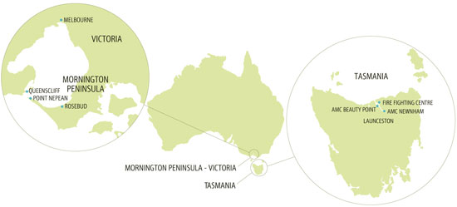
AMC Australia Location Map

